Mathworks Best Practices

- Mathworks Utilities
  - Checkout latest Mathworks Utilities to the project folder.
    - (SCM: Bobcat(mainline)/Tools/Mathworks_Utilities
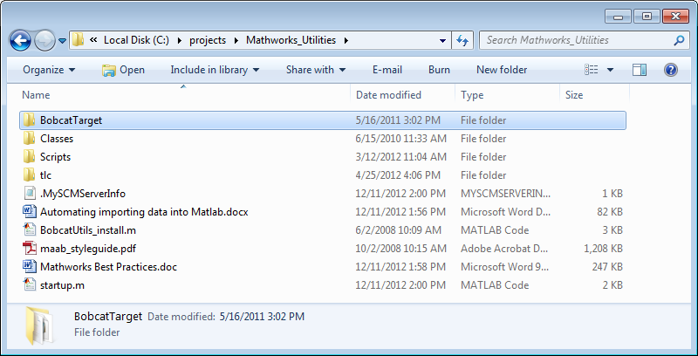

  - Move startup.m to C:\Program_Files\MATLAB\R20???\Work. You may need to create this folder (2009a and up).

    - This is necessary so that BobcatUtils_install.m will be run each time Matlab is started. BobcatUtils_install.m will set all the paths for the utilities. Startup also can be used to set the default configuration settings by selecting the preferred system target file.

    - Note: if you have changed the startup directory of matlab (by modifying its shortcut), then you will need to place startup.m in that directory.

- Loading Workspace Data
  - The preferred method for loading data to the workspace is to use an automated approach. Refer to “Automating importing data into Matlab.docx” for instructions.
    - Constant Data is imported from the machine database and the .c and .h files are also generated for the application code.
    - Defines and enums are imported from .h files in the application code.

  - If the project does not have a machine database, m files should be created to load the data manually. See example scripts in the Mathworks Utility folder and examples below.

  - A callback should be used in the Model Properties dialog to call the m-file when the model is loaded. This will automatically load the workspace when the model is opened. From Simulink, select File->Model Properties.

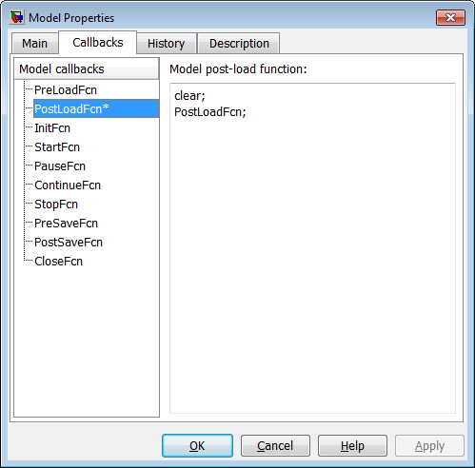

Examples of manual Workspace Script

- Constant Data – Parameters (non Table) can be created using the CreateCD function as follows:
CD_ECT_HIGH = Bobcat.Parameter; CreateCD(CD_ECT_HIGH, uint8(230), 'ConstantData', 'gstConstantData');

%function CreateCD(Name, Value, CustStrCls, StructName)
Name - constant data parameter name (should have a CD_ prefix)
Value – define data type and value (value will only be used in simulation) for fixed point use fi for data type such as fi(51/256,0,16,8)
'ConstantData' is the Custom Storage Class
'gstConstantData' is the constant data structure name

- Constant Data – Tables can be created using the CreateCDTable function as follows:
%function CreateCDTable(Name, matFile, CustStrCls, StructName, Path)

CD_ECT_TABLE_GAUGE = Bobcat.Parameter; CreateCDTable(CD_ECT_TABLE_GAUGE,'ECTGaugeTable','ConstantData', 'gstConstantData','DataTables\');

A “DataTables” folder should be created in the same folder as the model (Path).

The DataTables folder should contain .mat files which contain the table data.

The .mat filename can be anything, but the variable name in the .mat file must be “tableData”.

- Constant Data – Tables (alternate method)
%function CreateCDTable_basic(Name, StructName, vector)

CD_ECT_TABLE_GAUGE = Bobcat.Parameter; CreateCDTable_basic( CD_ECT_TABLE_GAUGE, 'CONSTANT_DATA_TABLES', [0:1:12]' );

It may be convenient to type the data vector. For example:
fi([0:1:12]',0,16,8) or uint8([0:1:12]')

Note that ‘vector’ must be a column vector.

This function assumes that your constant data tables are declared as array members of the ‘StructName’ structure. Accessing table entry i looks like this in generated: <StructName>.<Name>[i]

- Defines

Any constants defined in the model should be defined as parameters in the workspace (i.e. not as constants in Stateflow). Defines can be created using the CreateDefine function as follows:

%function CreateDefine(Name, Value, CustStrCls, HeaderFile)

STB = Bobcat.Parameter; CreateDefine(STB, uint8(5),
'Imported_Define', 'ap_defines.h');

- Global data structure access such as EEMirror in stateflow can be achieved by using the Data Store Block and setting it to resolve to a simulink signal object. The signal object can be created using the CreateEE (or similar) function as follows:

%function CreateEE(Name, CustStrCls, StructName)
EE_App_Data1 = Bobcat.Signal; CreateEE(EE_App_Data1, 'EEMirror', 'eeMirror');

Creating Custom Storage Classes

The “Classes” folder contains files which define all the Bobcat custom storage classes. A custom storage class is necessary if the model needs to access data/parameters from C code. Examples: Constant Data, EEMirror, constants/defines, etc.

To edit or add to custom storage classes type ‘cscdesigner –advanced’ on the MATLAB command line.

Select the “Bobcat” package. Note: Be sure to check out (and check in) the Classes folder if you edit or add to custom storage classes. Otherwise, this info will be missing if someone else tries to use your project.

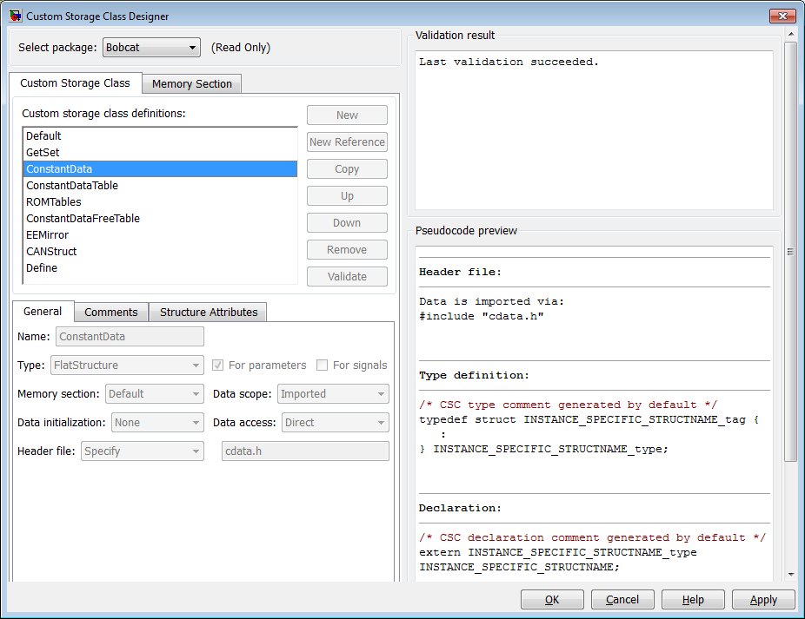

- Simulink Configuration Parameters
  - Recommended settings for Simulink Simulation->Configuration Parameters is as follows:

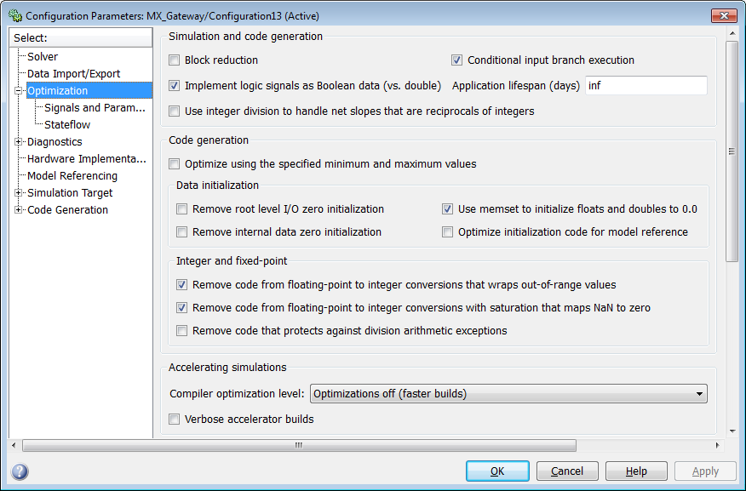
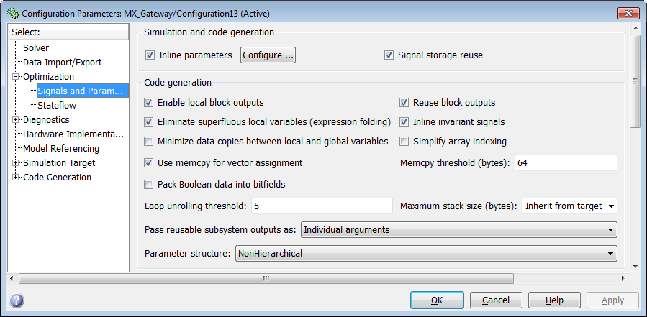
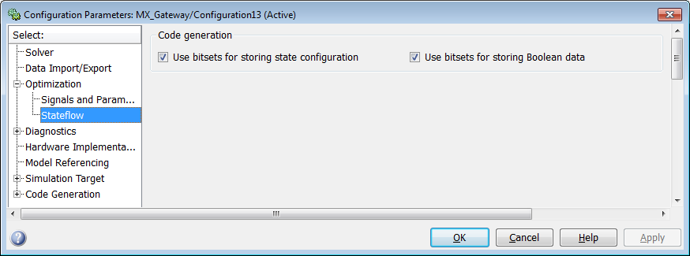

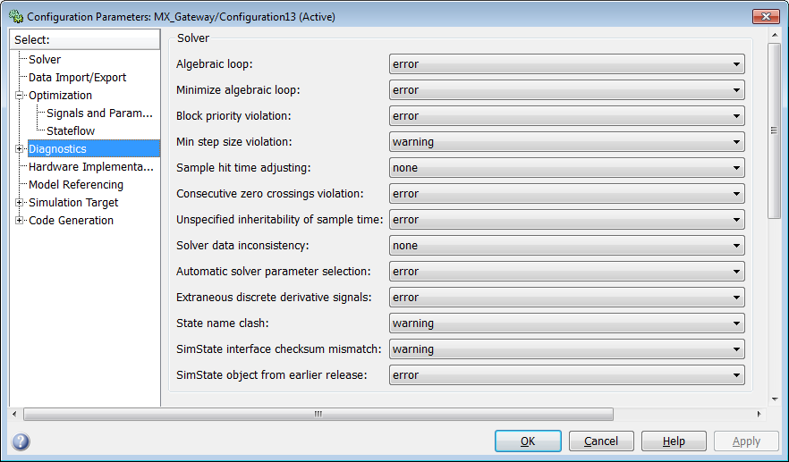
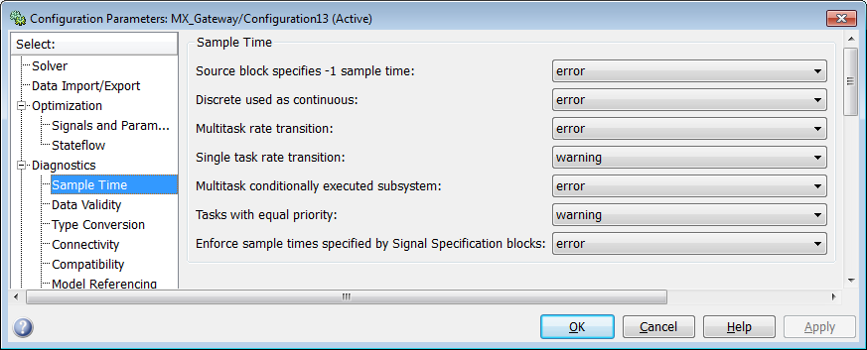
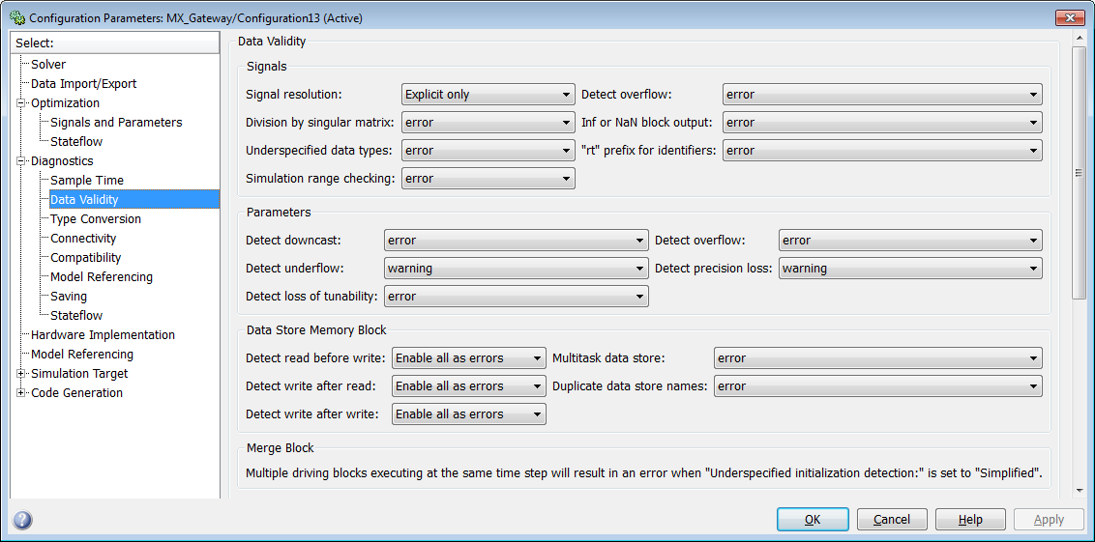
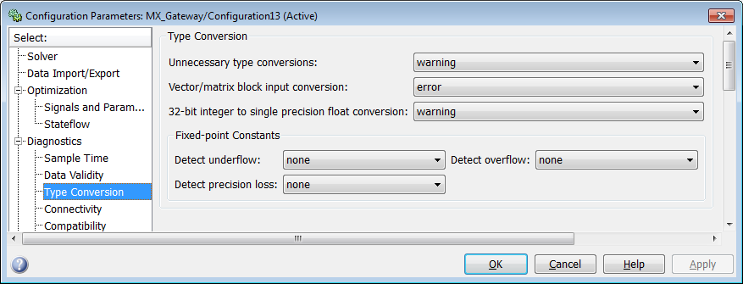
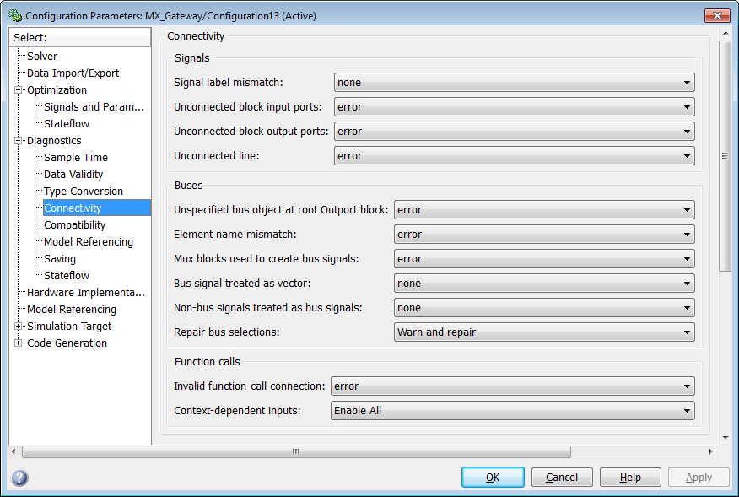
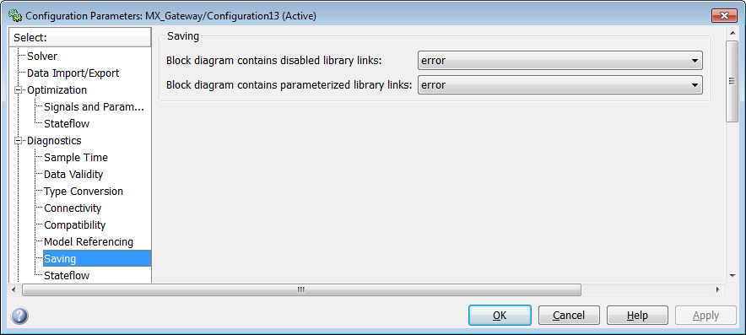
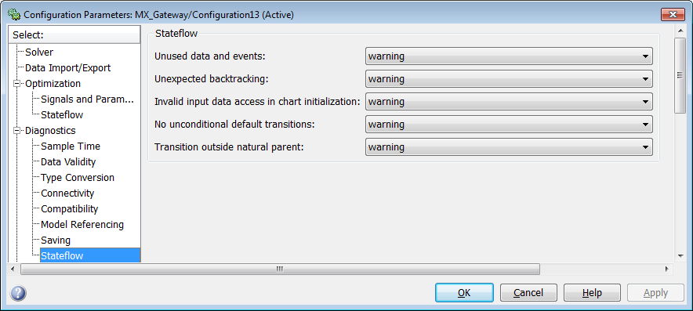
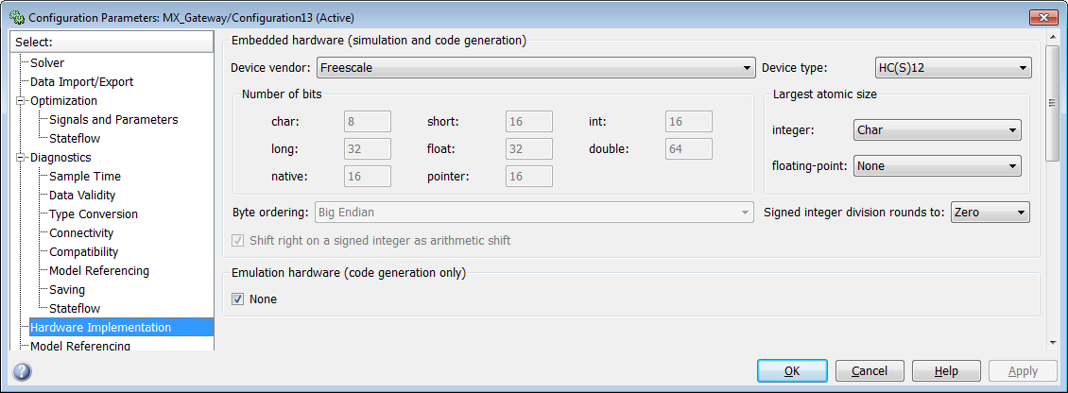
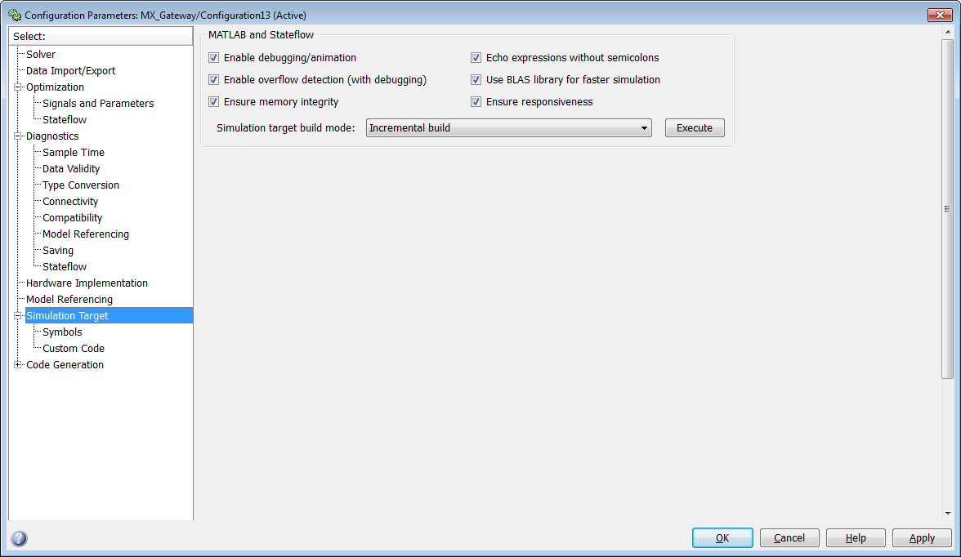
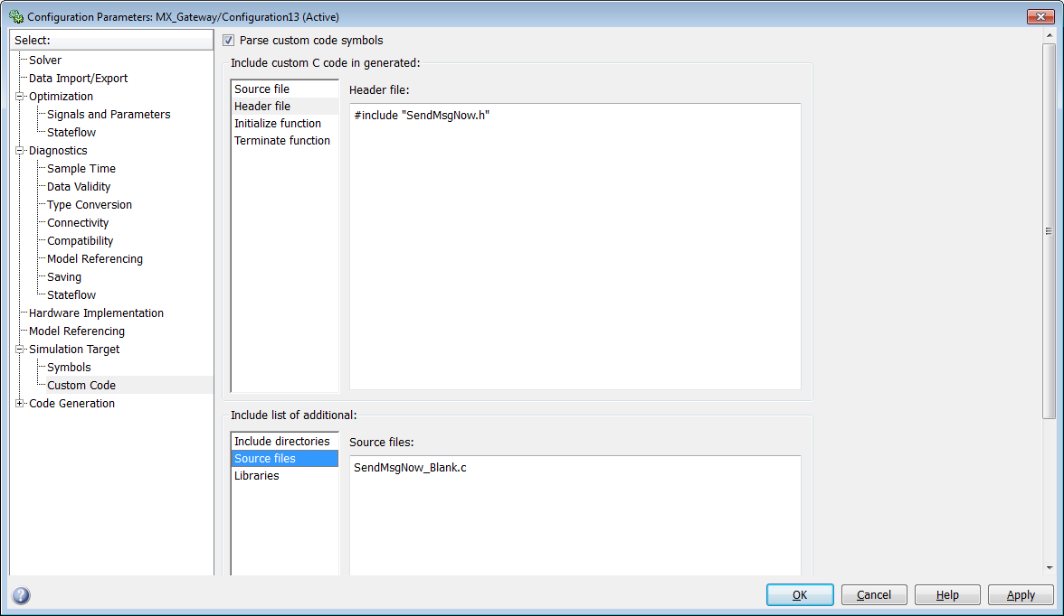
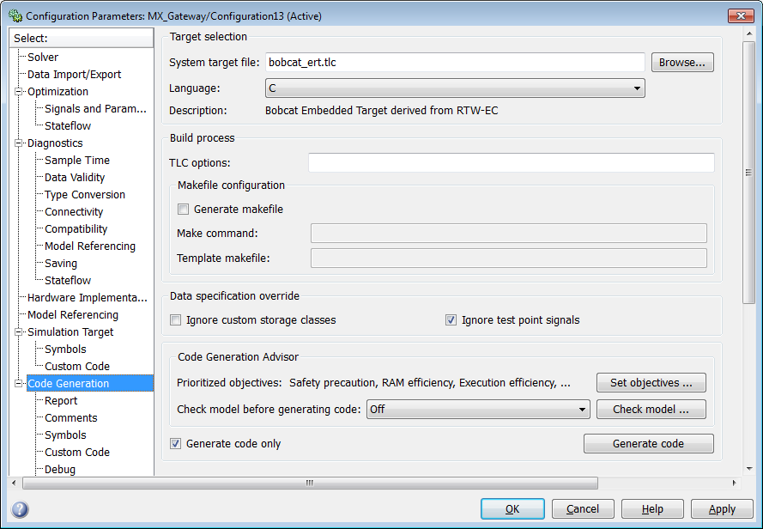
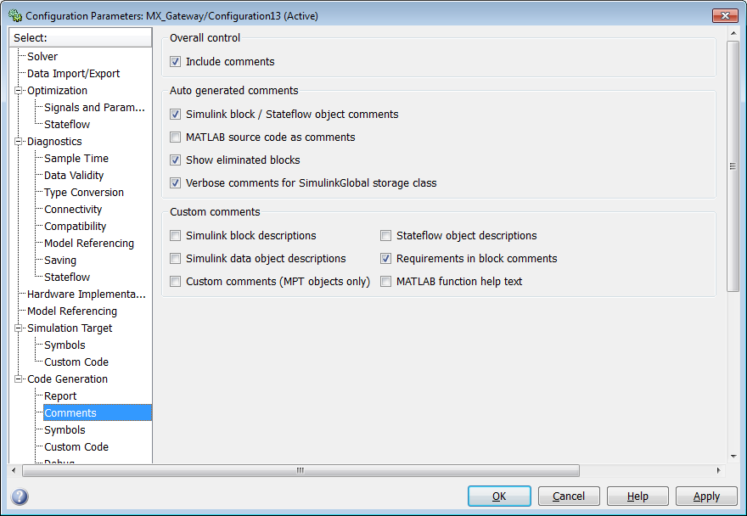

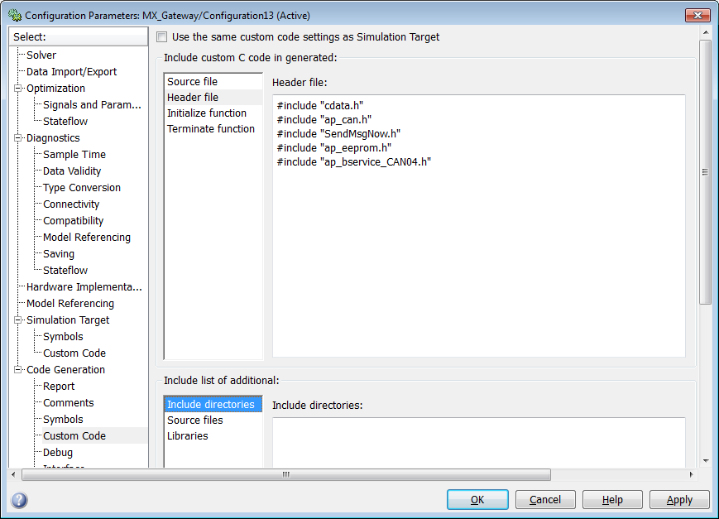
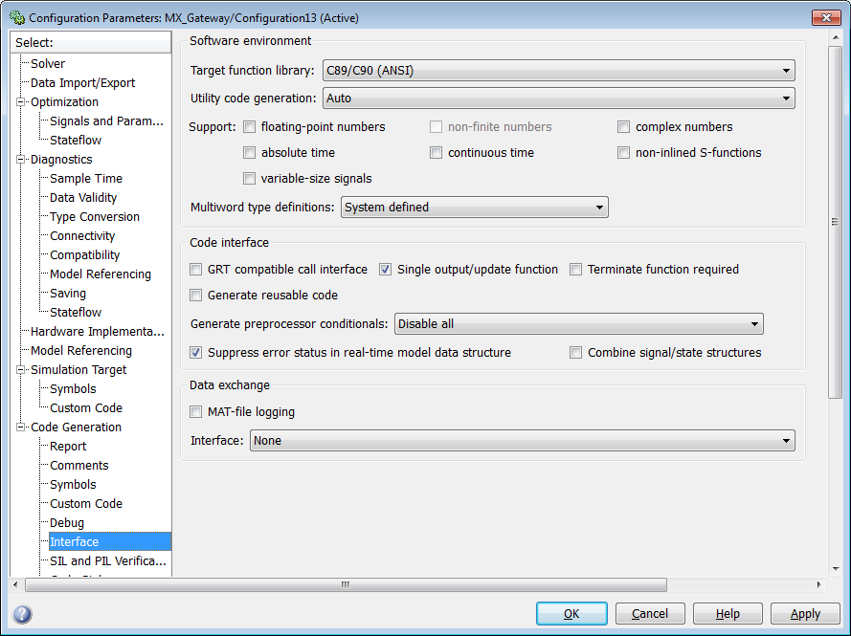
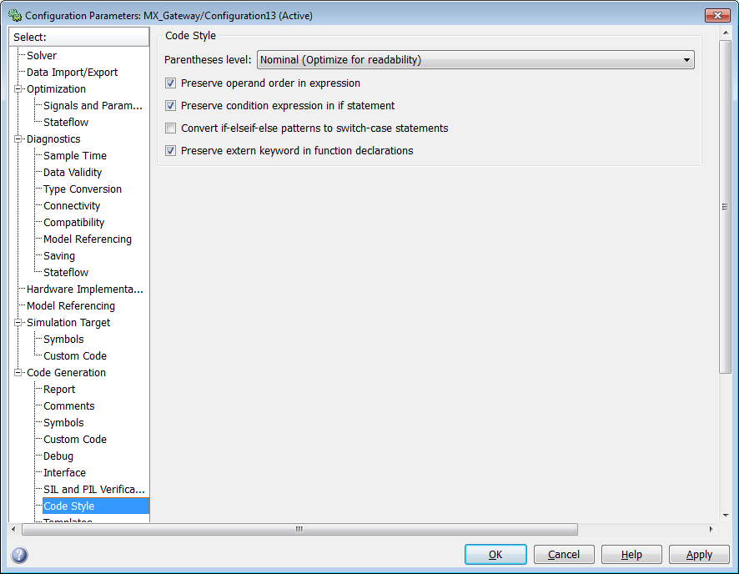
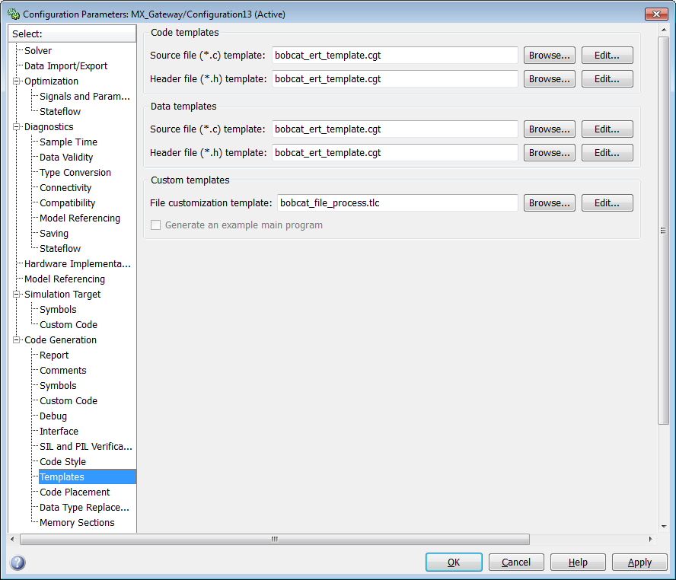

- Model Design
  - Do not use model reference.
  - Make an effort to follow requirements of maab_styleguide (Found in Mathwork Utilities).
    - Exceptions
      - Naming of signals only required when necessary to define input and output variables required to interface with application code
  - Use libraries for model blocks that are reused serveral times in a model.
    - Each application should have it’s own library to ensure changes to library for one application do not affect the other.
    - New projects should use libraries from other projects whenever possible
  - Run model advisor on your model to help identify issues
    - Simulink: Tools->Model Advisor
    - Load configuration file “model_advisor.mat” file (found in Mathwork Utilities) to load the preferred set of check to run on the model
    - Run early in the development process

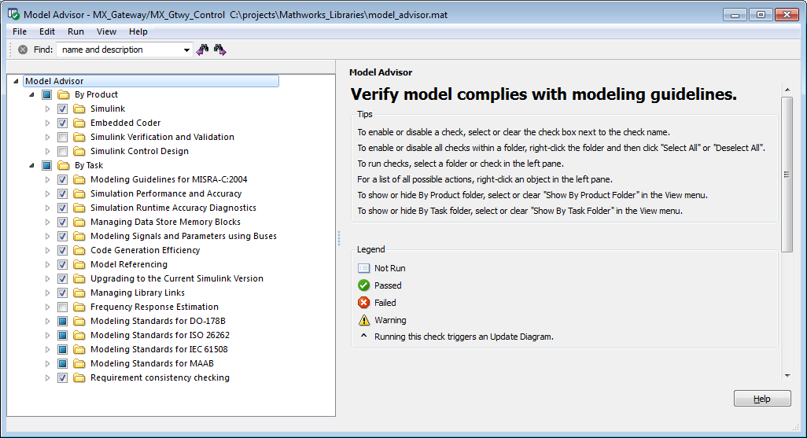

- Function Calls
  - Use the following process to create a function call from Stateflow to interface with application C code.
  - From Simulink, Simulation->Configuration Parameters
    - Simulation Target/Custom Code
    - Fill in three items as shown below

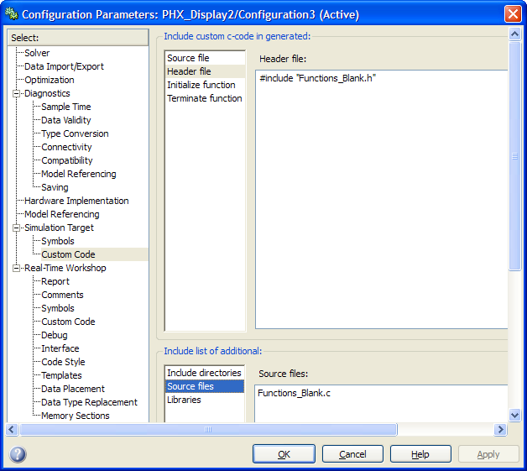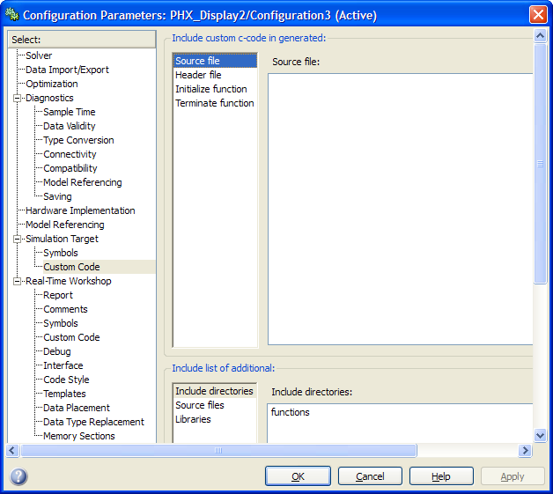

  - In C Configuration settings – add #include for wherever the real function prototypes are in code.
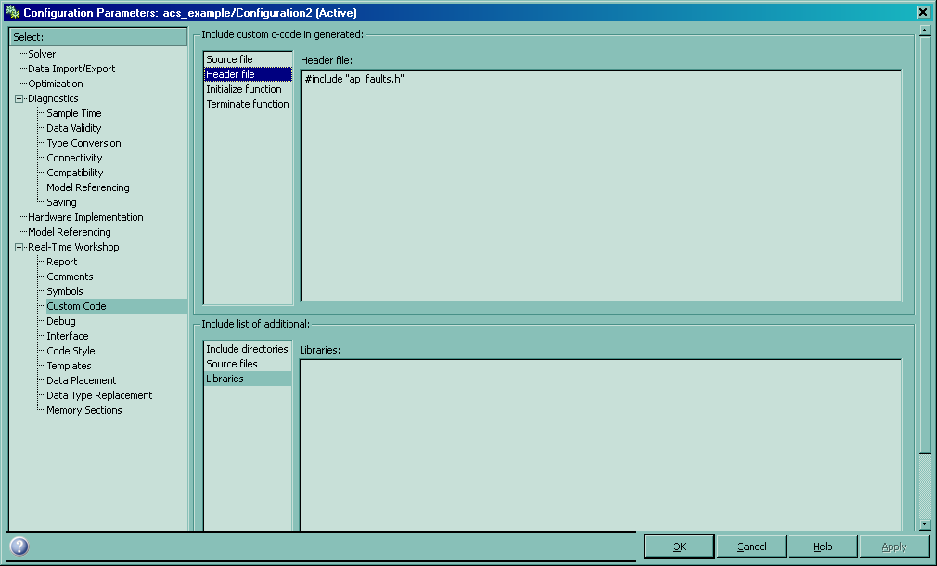
  - Create Function_Blank.c and Function_Blank.h in a functions sub-folder. Place the sub-folder wherever the model is located. Use standard C typedefs, not uint8, etc.

Example Function_Blank.c
void registerErrorCode(unsigned char function, unsigned char failure, unsigned int mask)
{

}

void eeUpdateRequest(unsigned char section)
{

}

Example Functions_Blank.h
#ifndef Functions_Blank_h
#define Functions_Blank_h

void registerErrorCode(unsigned char function, unsigned char failure, unsigned int mask);
void eeUpdateRequest(unsigned char section);

#endif

